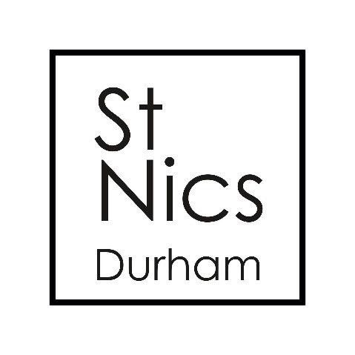

**About us:**

St Nics is an open evangelical church based in the heart of the City of Durham. As part of the Church of England we have a diverse community of 300 regular attenders across all age ranges. Based in the University City of Durham St Nics has a long established ministry with students over decades. This vacancy arises after the departure of our previous student and international worker to train for ordained ministry.

For decades St Nics has developed a ministry with international students and scholars in our university city of Durham. As part of that ministry St Nics offers hospitality to visiting students, scholars and their families every Wednesday evening in the form of a coffee/social event called Amigos. This takes place usually on church premises with the help of committed volunteers. We are a registered member of HK church.

Our student ministry is in good health with a team of assistant student workers, a thriving mid-week student night and a network of established small groups. We have good relations with the main Christian student bodies in the city including Just Love, Fusion and the Durham Intercollegiate College Union alongside college chaplains from across the University.

Having been designated a resource church by the Diocese of Durham St Nics is in an exciting time of both transition and growth with a renewed focus on discipleship, with a particular emphasis upon spiritual growth, numerical growth and growth in service amongst young people and students. This is part of our overall vision for the church as a growing community centred around Discipleship, Evangelism, Justice and Service.